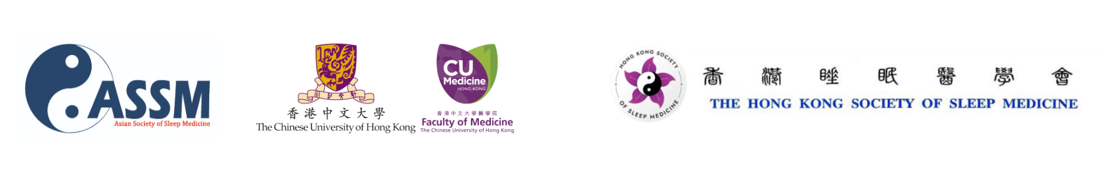
ASSM 2026 Young Investigator Award Application

Overview of Awards
The Young Investigator Award at ASSM interim meeting 2026 is designed to recognise and support outstanding early-career researchers in the field of sleep medicine and sleep science. Young Investigator Awards will be offered to both oral abstract presenters and poster presenters.

Requirements:
- Applicants must be 40 years old or younger, OR within 5 years of obtaining their MD or PhD degree.
- The applicant must present the accepted abstract at ASSM interim meeting 2026, either as an oral or poster presentation.

Application Process
STEP ONE – Submit your abstract online and indicating oral presentation or poster only.
STEP TWO – Please fill out the form below and send to assm-interimmeeting2026@cuhk.edu.hk.

Deadline: 17 Jul, 2026
The award recipients will be notified by 1 Aug, 2026.
Section 1: Please list your contact information and abstract details.
Full Name:
Age (years)
Email:
Position:
Affiliation:
Date of MD/PhD Completion:
Title of Abstract:
Abstract Number:
Section 2: Please list the contact details of a mentor or advisor who can verify you meet the requirements.
Mentor/Advisor Name:
Mentor/Advisor Email:
Mentor/Advisor Position:
Mentor/Advisor Affiliation:
Section 3: Please submit your biosketch and a personal letter highlighting the significance and impact of your submitted work to sleep medicine, and your reasons for applying for this award.
Biosketch (max 200 words)
Personal Letter (max 200 words)

